**Yakindu Research Report**

**Model Driven Development**

Model Based Software Engineering makes systematic use of (formal) engineering models as primary engineering artifacts throughout the overall engineering life cycle.

Model Driven Software Development (MDSD) is a generic term for techniques that transform formal models into executable software.

Model Driven Development (MDD)

Simplification by abstraction

• hide complexity

• focus on domain relevant aspects

• Generator encapsulates technical details

Transformation to target platform using generators (or interpreters)

• avoid redundancy (DRY: Don‘t Repeat Yourself)

• enforce architecture and design guidelines

• improve quality / reduce error rate / fix errors once

• improve productivity

• more flexibility for variants

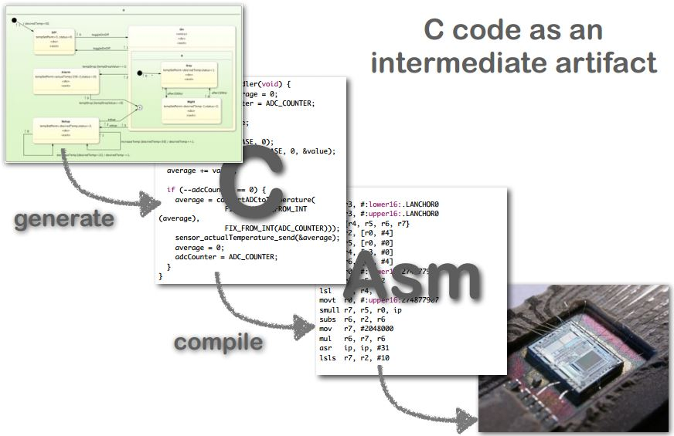**Abstraction Levels**

**When is MDD applicable?**

• same solution for the same problem

• schematic technical implemenation

• differences can be specified in the model

• less effort for specification than for implementation

• critical mass will be reached

• extent of models

• frequency of change

• number of target systems

• many variants

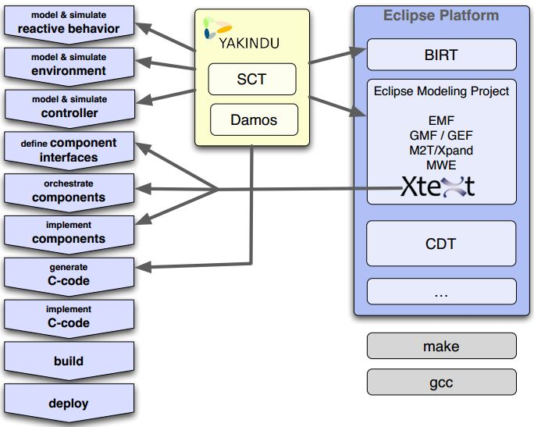**Activities and Tools**

**Damos Block Diagrams**

**Statecharts**

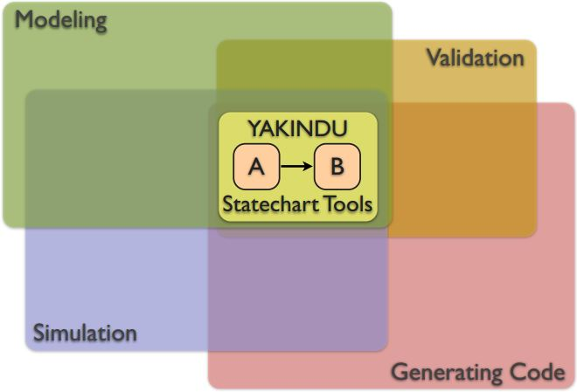**What are YAKINDU Statechart Tools ?**

The statechart tools are one central part of YAKINDU: the modular toolkit for model driven development of embedded systems. It is based on the open source development platform Eclipse. The YAKINDU Statechart tools provide the following tools to deal with state machine diagrams:

* **YAKINDU SCT editor** to create and edit state charts
* **YAKINDU simulator** to simulate the behavior of state charts
* **YAKINDU Xpand generator projects** to create a transformation of the state chart in Xpand
* **YAKINDU Xtend/Java generator projects** to create a transformation in Xtend/Java
* integrated validation

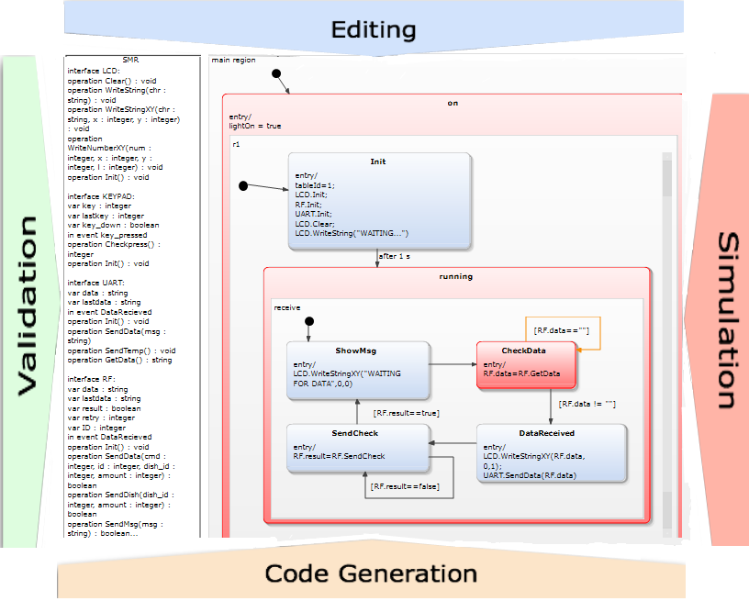The following graph shows these features and their relation to each other:

**Who is behind YAKINDU Statechart Tools 2?**

The main part of YAKINDU SCT 2 is an open source project ([www.yakindu.org](http://www.yakindu.org/) ). Most of the developers work for itemis; a well-known consulting company specialized on model-based development.

**Who uses the YAKINDU Statechart Tools 2?**

Initially the YAKINDU SCT 2 were designed for the embedded systems industry: automotive, system controls, vending machines etc. However, it brings benefit to everyone who needs to design, simulate and develop behavior. People can use the YAKINDU SCT 2 to generate Java, C, or C++.

**Finite State Machines**

A finite number of states defines a system. The behavior of the system depends on the current state; behaves differently to events depending on the state. The current state is determined by the history of the state machine.

**An example**

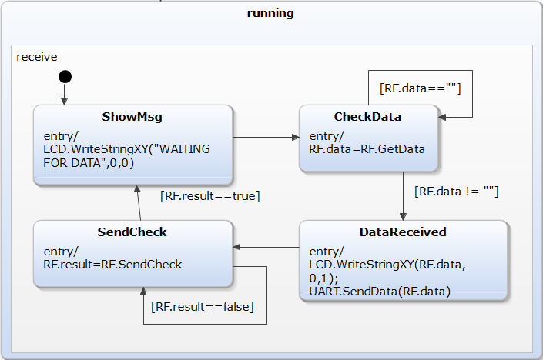

**Events**

• Trigger transitions

• And actions

**Variables**

• Hold quantitative values

• Accessible

• Modified by actions

**States**

• Behavioral equivalence classes

• Execute actions on entry, exit & continuously (do)

• Stable between events

**Transitions**

• Switch between states

• Triggered by events

• Guarded by Boolean expressions

• execute actions

• „takes no time“

Run to completion step is the atomic operation of a state machine which transforms from one stable state to the next. The system does not remain between states.

**Statecharts semantics**

Statecharts semantics using an own, simple meta model and close to UML state machines. However, YSCs are self-contained with an interface well defined by events and variables. Core execution semantics are cycle-driven and not event-driven, so they allows processing concurrent events and event driven behavior can be defined on top. Time is an abstract concept for statecharts. Time control is delegated to the environment. Model interpreter and different flavors of generated code follow the same core semantics.

**Installation**

### Prerequisites

The **Yakindu Statechart Tools 2** are built upon Java and Xtext. So you need to have installed a [Java Runtime Environment](http://www.oracle.com/technetwork/java/index.html) and Xtext installed. The easier way to get this is to install the [pre configured Xtext contribution](http://xtext.itemis.com/).

The **Yakindu Statechart Tools 2** need **Eclipse Indigo 3.7** or higher and **Xtext 2.0.1** exactly (no higher) to work correctly.

### Installing the YAKINDU-Plug-Ins

You install the Yakindu Plug-Ins from the update site: *http://updates.yakindu.com/juno/milestones*

* Click **Help** > **Install new software...** and **Add...** the update site Yakindu SCT2 milestones - *http://updates.yakindu.com/juno/milestones*
* Check all to install the YAKINDU SCT2
* Click **Next** to start the installation and click **Next** at the next step
* Accept the license agreement and click **Finish**
* The software will be installed

When the installation finished the wizard will ask to reopen Eclipse. The restart is important to 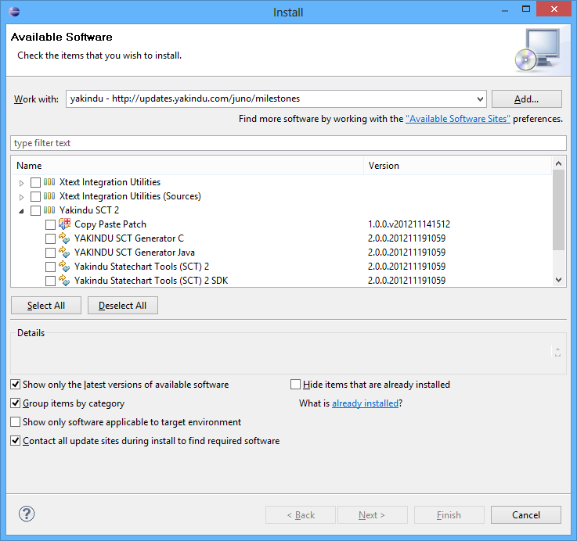make the newly installed software work correctly.

## **First steps: my first state machine**

In the following, you will create your first state machine with the YAKINDU Statechart tools and simulate it.

### Creating a New Project

For modeling purposes, the YAKINDU statechart tools offer a workbench perspective. Such a perspective is a bunch of editors and views that are organized in a pre-defined order on the screen. Open the Yakindu **SC Modeling** perspective by clicking **Window** > **Open Perspective** > **SC Modeling**. This perspective is optimized for statechart modeling. It consists of

* *Project Explorer* on the left
* *Outline* View on the right
* YAKINDU Statechart Editor at the top
* *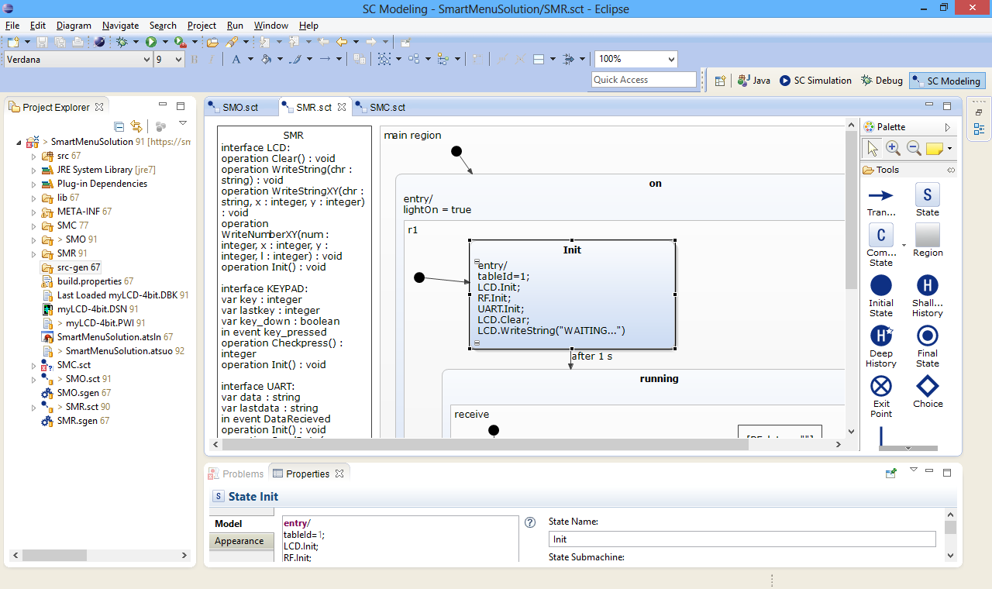Problems* and *Properties View* at the bottom
* In the Eclipse workbench, all elements are organized in projects. So first, to do is to create a project. Therefore click **File** > **New..." > *Project**. In the wizard click **Next** and insert a project name. Click **Finish**.
* Now you see your project in the project explorer.

**Defining a State Machine**

In the new project now, create a new statechart model:

1. Click **File** > **New** > **Other...** > **YAKINDU** > **YAKINDU Statechart Model**
2. Click **Next** and name the sct file
3. Click **Finish**
4. The YAKINDU statechart editor opens on the statechart model. It already has an initial state and an unnamed simple state connected by a transition.

The newly created model has a problem. The new state has a red dot with a cross. This is an error marker. If you look at the problems view (the **Problems** tab), you see more details to that problem. In that case, it says: “A state must have a name”.   
To solve the problem:

1. Click in the name field of the state and type the name ‚off’.
2. Click **File** > **Save**.

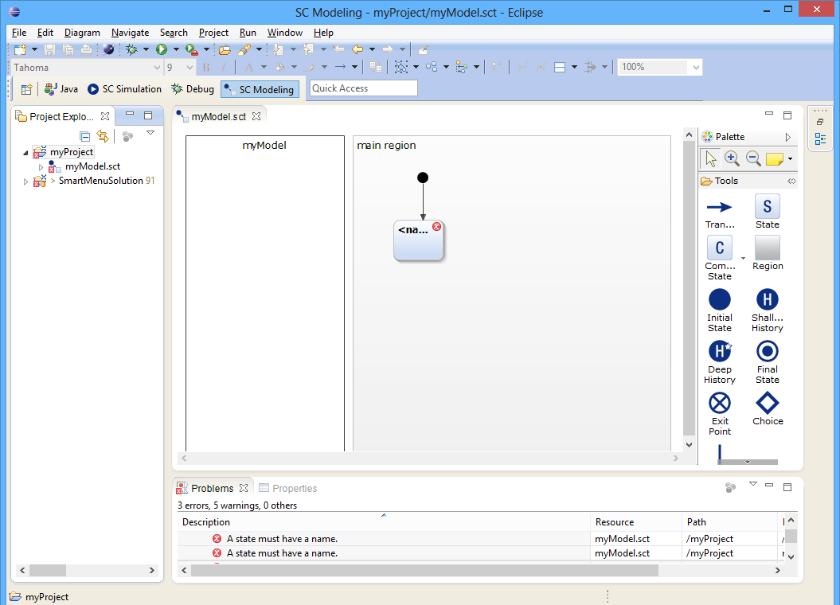The error marker and the entry in the problems view vanish.

With the **YAKINDU Statechart editor,** you create or modify state models. The editor automatically opens on .sct files.

The editor consists of three parts:

* the graphic canvas to design the state machine
* the palette on the right that owns the elements to design the state machine
* 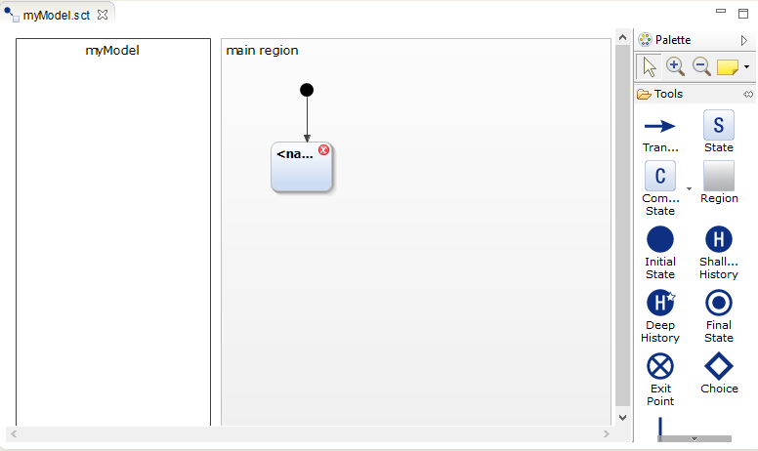a textual modeling field on the left

You can use the textual modeling field for declaration internal behavior of states and events or variables. The editor also owns comfortable functionality like syntax highlighting, code completion, live validation. 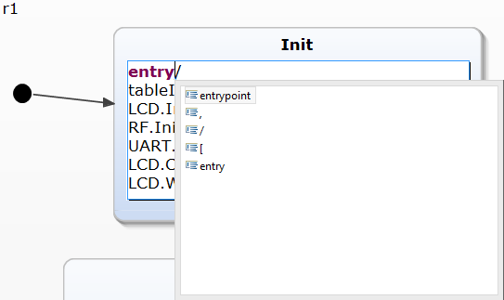The following image shows an example of code completion in the text fields of the editor:

1. Add a second state
   1. Click on the symbol **State** in the palette
   2. Draw a state icon in the main region
   3. Name the second state 'on'
2. Draw a transition from ‚off’ state to ‚on’ state.
   1. Click on the symbol **Transition** on the palette.
   2. Draw a line from ‚off’ to ‚on’.
   3. Add the following statement to the transition: after 2s.
3. Draw a transition with an event from ‚on’ to ‚off’ state.
   1. Click on the symbol 'Transition'
   2. Draw a line from off to one state.
   3. In the declarations, view add the statement internal: event switchOff.
   4. To the transition add the text switchOff

### Simulating the State Machine

• Model interpreter allows interactive simulation that helpful for finding errors.

• API is for simulation engines, interacts with devices, and visualizing device state. Currently, it does not have real debug capability.

YAKINDU SCT 2 comes with a perspective to simulate the models. To simulate a state machine open the Yakindu **SC Simulation** perspective by clicking **Window** > **Open Perspective** > **SC Simulation**. This perspective is optimized for simulation purposes and consists of:

* *Project Explorer* on the left
* *Outline* view on the right top
* Simulation View on the right bottom
* Debug view at the top
* YAKINDU Statechart Editor

The simulation view is an interactive view to watch and control the state machine simulation. To get it open the simulation perspective.

1. Start the simulation by clicking **Run** > **Run**.
2. The simulation starts and state ‚off’ is red for 2 seconds. Then state ‚on’ gets active (red).
3. Raise event‚ switchOff’: Click on‚ switchOff’ in the simulation view.
4. State ‚off’ is active again for 2 seconds.
5. Stop the simulation: **Run** > **Terminate**.

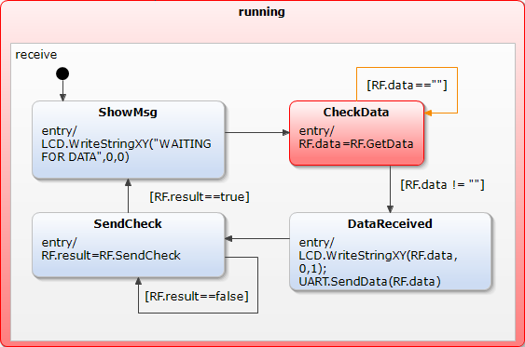During the simulation in the statechart editor, the active state gets a red color. The previous transition is green. The simulation view shows the events that trigger the states. You can change values here to trigger events. Beneath the table, there are two clocks. One for the virtual time and one for the real time and a slider to change virtual time.

# Yakindu Statechart tool concepts

## Modeling

Yakindu Statechart Models are based on statecharts as defined by David Harel and are close to UML state machines. Thus, they support all structural model elements as defined by the UML specification, which are States (orthogonal and hierarchical), Regions, Transitions and Pseudo States (History, Deep History, Initial, Final, Choice, Join / Fork).   
In addition, Yakindu Statechart Models specify interfaces that define the interaction of the state machine with its environment. Besides some more advanced concepts like Entry / Exit Points, an interface basically consists of in and out Events as well as Variables including types. These well-defined statechart interfaces are especially useful in the context of component models and product line engineering.

For defining interfaces and modeling the dynamic aspects of statecharts (triggers, guards and actions) SCT provides a statically typed, textual action language. It tightly integrates into the graphical editor and supports the user with code completion, syntax highlighting, cross referencing and validation during modeling.

Declarations of interfaces, events, variables etc. are done in a textual modeling field in the editor. The language expressions that define actions are directly added to the elements like states or transitions.

## Simulation

Yakindu Statechart Models can be executed via an integrated simulation engine. The simulation engine supports two different types of execution semantics:

* cycle based
* event driven

The default execution semantic is **cycle based** which executes a statechart cycle within a fixed period of time and thus allows processing of concurrent events. In contrast, the **event based** approach executes a statechart cycle as soon as an event occurrs.

During simulation, the currently active states and the transition path including the previous states are highlighted in the editor for visual debugging. An additional view shows the variable values and allows to raise events.

Apart from that, the engine uses a **virtual time** during simulation. The user can provide a time scaling factor that is multiplied with the real time. This is especially useful during debugging, if the statechart model contains very tight or long running time triggers.

## Code Generation

Yakindu Statechart Tools currently support the generation of Java, C and C++ Code. All generators can be customized with a **generator model**. This is a textual model file where generator features, like the execution type (event or cycle based), or the interface styles (static or generic), can be specified. The code generation process can either be executed with a builder that starts code generation on resource change or manually with a context menu action.

## Domain specific adaptability

Yakindu Statechart Tools were developed with a domain specific adaptability in mind. Several extension points allow the customization of all mentioned aspects. It is possible to contribute a custom type system or custom action languages which may be a dialect of the textual description language or a complete new language.

Also, the different code generators can be customized or new code generators for other target languages can be plugged in easily.

## Yakindu SC Modeling perspective

For state machine modeling purposes open the Yakindu **SC Modeling** perspective by clicking **Window** > **Open Perspective** > **SC Modeling**. This perspective is optimized for statechart modeling. It consists of

* [Project Explorer](http://127.0.0.1:3236/help/topic/org.yakindu.sct.doc.user/help/user/03_Concepts/PLUGIN_ROOT/org.eclipse.platform.doc.user/concepts/cnav.htm) on the left
* [Outline](http://127.0.0.1:3236/help/topic/org.yakindu.sct.doc.user/help/user/03_Concepts/PLUGIN_ROOT/org.eclipse.platform.doc.user/concepts/coutline.htm) View on the right
* YAKINDU Statechart Editor at the top
* 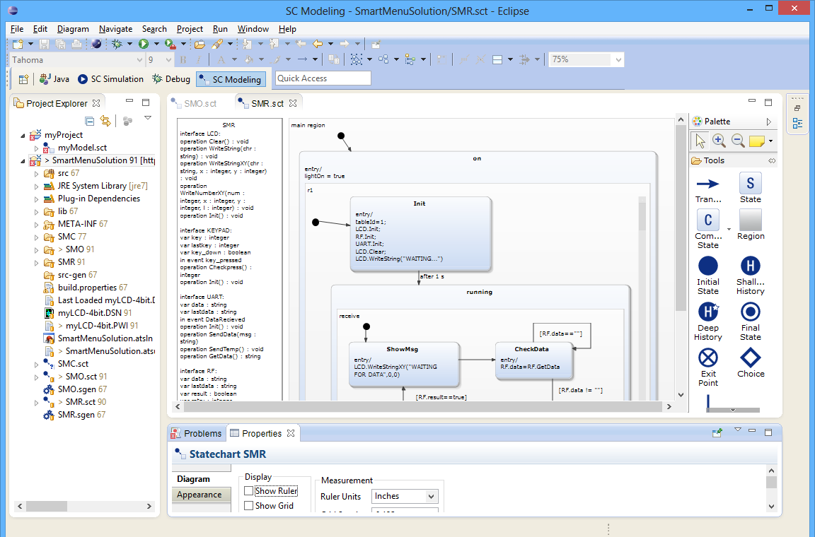[Problems](http://127.0.0.1:3236/help/topic/org.yakindu.sct.doc.user/help/user/03_Concepts/PLUGIN_ROOT/org.eclipse.platform.doc.user/concepts/cprbview.htm) and [Properties View](http://127.0.0.1:3236/help/topic/org.yakindu.sct.doc.user/help/user/03_Concepts/PLUGIN_ROOT/org.eclipse.platform.doc.user/concepts/cpropview.htm) at the bottom

## Yakindu SC Simulation perspective

To simulate a state machine use the Yakindu **SC Simulation** perspective by clicking **Window** > **Open Perspective** > **SC Simulation**. This perspective is optimized for simulation purposes and consists of:

* [Project Explorer](http://127.0.0.1:3236/help/topic/org.yakindu.sct.doc.user/help/user/03_Concepts/PLUGIN_ROOT/org.eclipse.platform.doc.user/concepts/cnav.htm) on the left
* [Outline](http://127.0.0.1:3236/help/topic/org.yakindu.sct.doc.user/help/user/03_Concepts/PLUGIN_ROOT/org.eclipse.platform.doc.user/concepts/coutline.htm) view on the right top
* Simulation View on the right bottom
* Debug view at the top
* YAKINDU Statechart Editor at the bottom

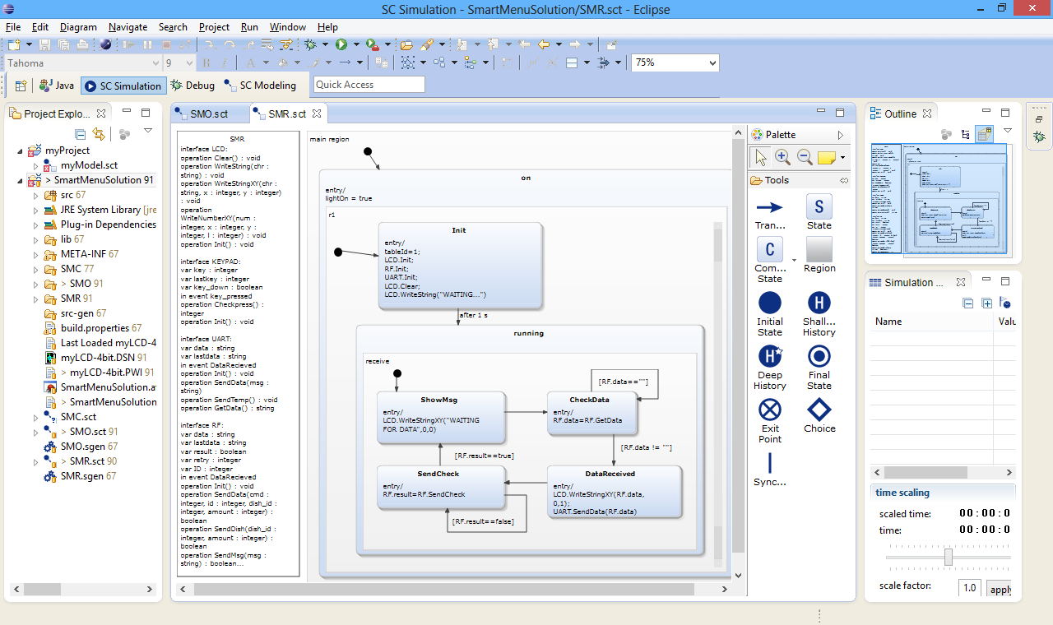

## YAKINDU Statechart Editor

With the YAKINDU Statechart editor you create or modify state models. The editor automatically opens on .sct files. To create a new YAKINDU statechart model click **File** > **New** > **Other...** > **YAKINDU Statechart model**. Give it a speaking name and click **Finish**. The ****newly created model opens in the statechart editor. Also the SC Modeling perspective opens.

The editor consists of three parts:

* the graphic canvas to design the state machine
* the palette on the right that owns the elements to design the state machine
* a textual modeling field on the left

You can use the textual modeling field to define internal behavior of states and declare events or variables. The [reference](http://127.0.0.1:3236/help/topic/org.yakindu.sct.doc.user/help/user/05_Reference/reference.html#Statechartdescriptionlanguage) explains this language.

Elements that cause problems get warning and error markers attached. For more details about the problems open the **Problems View**.

## Simulation View

The simulation view is an interactive view to watch and control the state machine simulation. To get it open the simulation perspective.

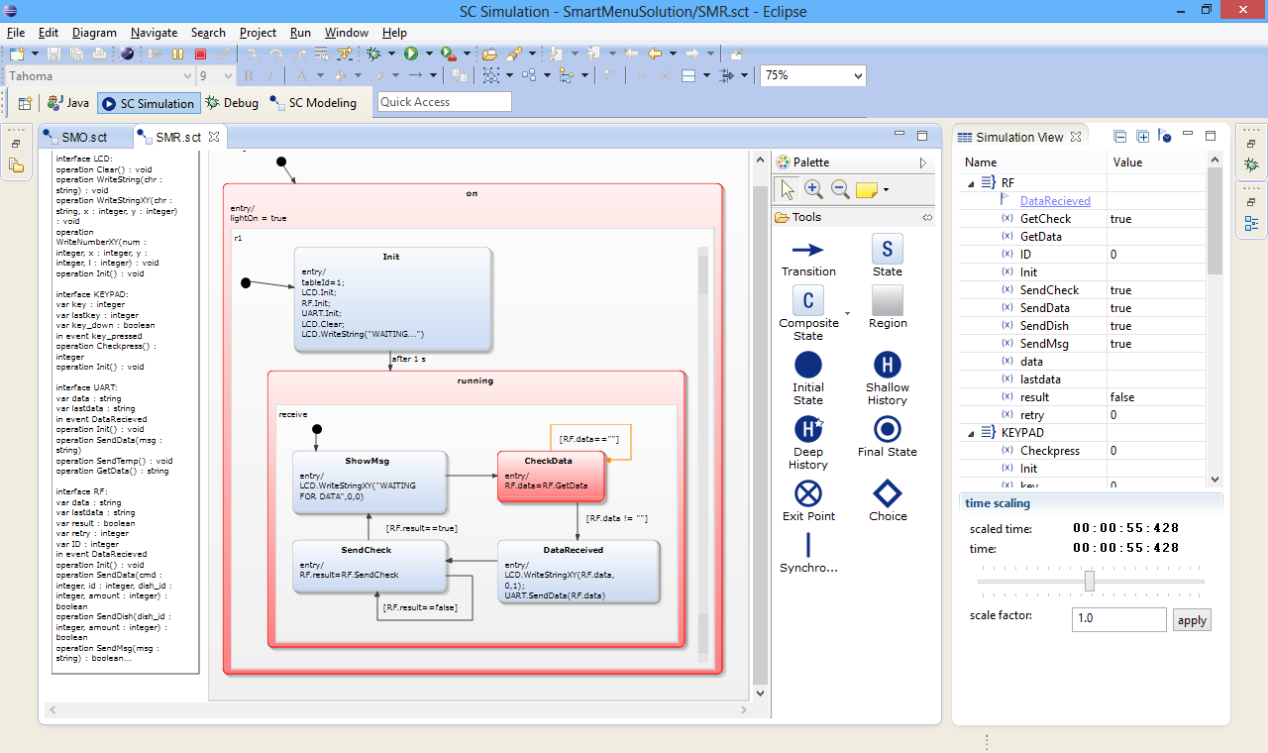Start a simulation by clicking **Run** > **Run**.

During the simulation in the statechart editor, the active state gets a red color. The previous transition is green. The simulation view shows the events that trigger the states. You can change values here to trigger events. Beneath the table, there are two clocks. One for the virtual time and one for the real time and a slider to change virtual time.

You can also select an event driven or cycle based run configuration.

## YAKINDU SCT Nature

YAKINDU model projects are associated with the **YAKINDU SCT nature**. On projects with **YAKINDU SCT nature** .sct and .sgen files are automatically build and checked for problems. So you get fast feedback during editing. You can toggle the SCT nature by right clicking **Configure** > **Add** or **Remove YAKINDU SCT Nature** on the project.

# State chart elements

In the following the state chart elements of the YAKINDU SCT 2 editor are described. The meta model of the YAKINDU SCT 2 is the model of finite state machines. It is based on the view of a system that is defined by a finite number of states. The behavior of that system is based on the active states. These states are determined by the history of the state machine. Very important are the theoretical models for state machines by Mealy and Moore. Mealy state machines associate actions with transitions. Moore machines associate actions with states (entry, exit). In the YAKINDU SCT 2 both is possible.

The YAKINDU SCT 2 meta model is designed similar to the UML state chart meta model with the following differences

* they are self contained with interfaces defined by events and variables
* core execution semantics are cycle driven, not event driven
  + this allows to process concurrent events
  + event driven behavior can be defined on top
* time is an abstract concept for state charts
* time control is delegated to the environment

The model interpreter and different flavors of generated code follow these same core semantics.

Please refer to the description of the [UML Statecharts](http://en.wikipedia.org/wiki/UML_state_machine) for more details.

## Regions

As already mentioned the YAKINDU state charts are self contained. They are organized in regions. Due to this it is possible to organize multiple state machines in different regions and to run them concurrently.

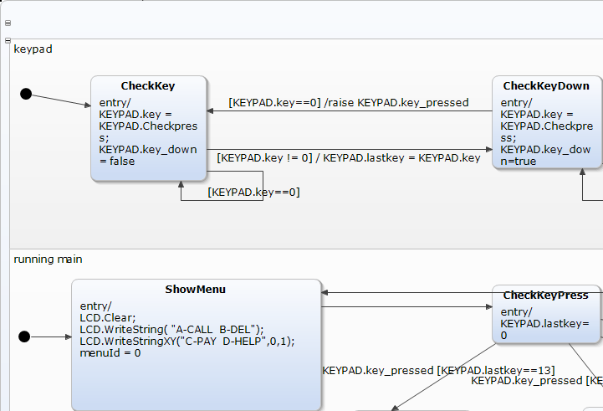

### States

States are the central elements of a state machine. A state has to be placed inside a region and needs a unique name inside this region. During simulation each state can be active or passive. An active state has actions that are accomplished. Either an action is carried out on entering a state, during active state or on exit.

### Transitions

A transition is the transfer of one state to another. Transitions are diagrammed as arrows and can carry events and actions but must not.

The syntax of events and actions is defined by a textual description language (#Statechartdescriptionlanguage). Please refer to the documentation section [Events](http://127.0.0.1:3236/help/topic/org.yakindu.sct.doc.user/help/user/05_Reference/reference.html?cp=18_4#Events) for more details. For more details on Actions refer to the chapter [Actions](http://127.0.0.1:3236/help/topic/org.yakindu.sct.doc.user/help/user/05_Reference/reference.html?cp=18_4#ReactionTriggers).

If a state has more than one outgoing transition without event that transition is carried out first that was modeled first.

### Initial state and final state

Initial and final states are pseudo states, because the state chart does not rest on them. Pseudo states express characteristics that are impossible to express by simple states.

The initial state is always the first state that is active during interpretation or simulation of the state machine. An initial state can only have one outgoing transition and no incoming. This transition has no events or actions.

Inside a region only one initial state is allowed, but every region can have an initial state.

### Choice

Choice is also a pseudo state. It can be used to model a conditional path. Choice nodes divide a transition into multiple parts.

Usually the first transition points towards the choice node. One of the choice outgoing transitions can carry a condition.

### Junction

A junction is a pseudo state do combine transitions. This is very comfortable if a state machine has many similar transitions. Junctions add clear arrangement to the state machine.

### Composite State

A composite state is a state that is composed of other state machines. These are also organized in regions. Besides the simple composite state YAKINDU knows two kinds of composite states: orthogonal state and submachine states.

Composite states contain other state machine branches.

## Statechart description language

The textual description language is used to declare and describe behaviors in the state machine. It is case sensitive.

### Typesystem

The language has an integrated small typesystem with the following simple types:

* integer
* real
* boolean
* string
* void

So events and variables can be declared with types:

var intVar : integer

var realVar : real

var boolVar : boolean

var stringVar : string

var voidVar : void

event addInt : integer

event checkValidity : boolean

For example:

**interface** RF:

**var** data : string

**var** lastdata : string

**var** result : boolean

**var** retry : integer

**var** ID : integer

**in** **event** DataRecieved

### Expressions

Expressions can be defined similar to other programming languages. The language offers operators to define logical expressions, bitwise arithmetic, and arithmetic expressions and bit shifting.

Logical expressions are similar to other programming languages. The return type is **boolean**. In the following there are some examples of these:

|  |  |
| --- | --- |
| Logical AND | var1 && var2 |
| Logical OR | var1 || var2 |
| Logical NOT | !var1 |
| Conditional expression | var1 ? var2 : 23 |
| Bitwise XOR | var1 ^ var2 |
| Bitwise OR | var1 | var2 |
| Bitwise AND | var1 & var2 |
| Logical Relations and Shift Operators | |  |  | | --- | --- | | less than | < | | equal or less than | <= | | greater than | > | | equal or greater than | >= | | equal | == | | not equal | != | | shift left | << | | shift right | >> | |
| Binary arithmetic operators | |  |  | | --- | --- | | plus | + | | minus | - | | multiply | * | | divide | / | | modulo | % | |
| Unary arithmetic operators | |  |  | | --- | --- | | positive | + | | negative | - | | circa | ~ | |

### Statements

A statements can be either an assignment, raising an event or call an operation. The language has the following assignment operators:

* simple assignment: =
* multiply and assign: *=
* divide and assign: /=
* calculate modulo and assign: %=
* add and assign: +=
* subtract and assign: -=
* bitshift left and assign: <<=
* bitshift right and assign: >>=
* bitwise AND and assign: &=
* bitwise XOR and assign: ^=
* bitwise OR and assign: |=

An event is raised by the keyword raise followed by the event name and if it is an interface event the name of the interface.

An operation is called similar to other programming languages with the operation name and passing concrete parameters. The parameters can be expressions.

### Scopes

#### Namespace

The language allows to define unique namespaces, which can be used to qualify references to the statechart.

namespace trafficlights

#### interface scope

Declarations in the interface scope are externally visible. They can be shared within the environment.

interface NamedInterface:

in event event1

out event event3

var variable1 : real

entrypoint entry1

exitpoint exit1

#### internal scope

Declarations made in an internal scope are only visible for contained states.

internal:

var localVariable1: integer

event localEvent: integer

local event localEvent2: NamedInterface.event1 || localEvent

local event localEvent3: localEvent || localEvent2 : 25

operation localOperation (integer, integer): integer

localEvent3 / raise NamedInterface.event3 :

localOperation(valueOf(localEvent),NamedInterface.variable1);

### Declarations

Within scopes there can be declarations of Events, Variables, Operations, LocalReactions, EntryPoints and ExitPoints.

### Events

Within interface scope events have an direction. They can either be ingoing or outgoing:

interface NamedInterface:

in event event1

out event event2

Within local scope events can carry variables:

internal:

event localEvent1 : integer

Local events can be derived from interface events or other local events and can have a value assignment:

internal:

event localEvent1: integer

local event localEvent2 = NamedInterface.event1 || localEvent1

local event localEvent3 = localEvent2 || 25

### Variables

Variables can have different visibilities. They can be visible for the environment:

var variable1: real

Variables can be **readonly** (constants):

var readonly pi: real = 3.1415

Variables can be referenced by the environment.

var external variable3: integer = 34

### Reaction Triggers

Actions are key constructs in state machines to model behavior. The YAKINDU SCT 2 knows the following kinds of actions.

#### after

The after trigger specifies one-shot time events.

After the specified time the reaction is triggered. An after trigger can be used in transitions of states as well in local reactions of states and statecharts. The specified time starts when the state or statechart is entered.

after 20 s

Structure:

after *time* ( *unit* )?

The time unit can be:

* s – seconds
* ms – milliseconds
* us – microseconds
* ns – nanoseconds
* empty – implies seconds

#### every

The every trigger specifies periodic time events.

The reaction is triggered periodically after the specified time. An every trigger can be used in transitions of states as well in local reactions of states and statecharts. The specified time starts when the state or statechart is entered and repeats periodically.

every 200 ms

Structure:

every *time* ( *unit* )?

The time unit can be:

* s – seconds
* ms – milliseconds
* us – microseconds
* ns – nanoseconds
* empty – implies seconds

#### always

This trigger is always true and enables a reaction to be executed in every run to completion step (RTS). It is equivalent to oncycle.

#### default, else

The default trigger is equivalent to the else trigger. It is intended for use for the outgoing transitions of choice pseudo states, to make sure that always an outgoing transition can be taken. It can only be be used in transitions and implies the lowest evaluation priority for that transition.

#### entry

An entry trigger marks actions that are carried out on entering a state or state machine.

#### exit

An exit trigger marks actions that are carried out on exiting a state or state machine.

#### oncycle

The oncycle trigger is always true and enables a reaction to be executed in every run to completion step (RTS). It is equivalent to always.

### Operations

Operations can have none, one or multiple parameters. The parameters are only declarated by their type. An operation can have one return type similar to Java.

operation localOperation (integer, integer):integer

localEvent3/ raise NamedInterface3.event1

### LocalReactions

Local reactions describe the internal behavior of a state. So they have internal scope. A local reaction is declared as follows:

LocalReaction: ReactionTrigger '/' ReactionEffect ('#' ReactionProperties)?

ReactionTrigger: (Event ("," Event )* (=> '[' Expression ']')?) | '[' Expression ']'

ReactionEffect: Statement (';' Statement )* (';')?

Statement: Assignment | EventRaising | OperationCall

ReactionProperties: (EntryPoint | ExitPoint)*

Within a local reaction an interface event can be raised:

internal:

localEvent1 / raise NamedInterface.event3 : localOperation (valueOf(localEvent), NamedInterface.variable1);

Local reactions can have priority values. These are defined by a following # and the integer number of priority:

localEvent2 / NamedInterface.variable2 += 3; #1

localEvent3 / NamedInterface.variable4 += 2.0; #2

### EntryPoints

Every state chart has an entry point. An entry point can be declared like the following:

entrypoint entry1

### ExitPoints

Every state chart has an exit point. This exit point can be declared like the following.

exitpoint exit1

## SGen

All generators can be customized with a generator model. This is a textual model file where generator features, like i.e. the outlet path, can be specified. The following screenshot shows an example configuration for the java code generator.

To get started with the generator model, we included a new Eclipse wizard that creates a basic 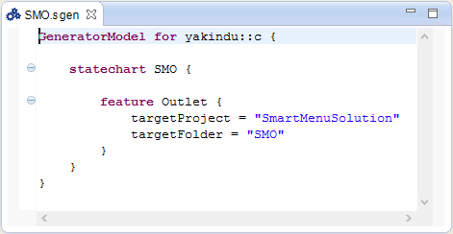configuration file with default values.

### Generator model for C

#### Feature Outlet

With the feature **Outlet** you define the folder the source files will be generated in:

feature Outlet {

targetProject = "org.terra.coffee.machine"

targetFolder = "src-gen"

}

#### Feature LicenseHeader

With the feature Licence header you can set a licence text that is added to the headers of all generated files:

feature licenseHeader {

licenseText = "Copyright (c) 2012 itemis AG.

All rights reserved."

}

#### Feature Debug

The feature debug controls the output of debug information. An important information source is the intermediate model sExec.

feature Debug {

dumpSexec = false

}

#### Feature CCodeFeature

feature CCodeFeature {

DebugType="DEBUG"

InterfaceEventListener=false

Singleton=true

}

#### Feature FunctionInlining